Steps to clean the data in Species and AOU code columns
Here we are explaining the steps we took to ensure the accuracy and consistency of bird species observations in a dataset titled 'updated_main_dataset.csv.' We aimed to check and clean the records using a trusted reference dataset: 'Atlantic Flyway CWB species list_with_team_input.xlsx.'
The two primary columns of interest were:
- Species (Common name of the bird)
- AOU_codes (American Ornithological Union numeric codes)
We compared these values with a trusted reference list to retain only valid and meaningful entries for further analysis.

Cleaning Process:

Step 1: Loading the Datasets: The first step involved importing both the main dataset and the species reference dataset using pandas:

Code: main_df = pd.read_csv('updated_main_dataset.csv')
ref_df = pd.read_excel('Atlantic Flyway CWB species list_with_team_input.xlsx')
- The main dataset contains bird observations and associated metadata.
- The reference dataset is a validated list of colonial waterbird (CWB) species along with their official AOU codes.

Step 2: Preparing the Reference Lists: To make sure the data was accurate, created two lists:
- valid_species: All non-null common names from the reference dataset.
- valid_aou_codes: All non-null AOU codes from the reference dataset.
Code: valid_species = set(ref_df['COMMON NAME'].dropna())
valid_aou_codes = set(ref_df['AOU CODE'].dropna())

Step 3: Filtering the Dataset: The main dataset was then filtered to retain only records where either:
- The Species is missing (NaN) or is found in the valid species list, OR
- The AOU_code is missing (NaN) or is present in the list of valid AOU codes.
Code: filtered_df = main_df[
(main_df['Species'].isna()) | (main_df['Species'].isin(valid_species)) |
(main_df['AOU_codes'].isna()) | (main_df['AOU_codes'].isin(valid_aou_codes))
]
This method helps us manage:
- Valid data: Where either the Species or AOU code is correctly listed.
- Incomplete but usable data: Where one field is missing but the other is valid.
- Invalid data: Where both fields are present but neither is recognized.

Results & Output:
- The cleaned dataset was saved as 'filtered_main_dataset.csv'
- Any rows with both unrecognized species and unrecognized AOU codes were excluded.
- This results in a dataset with better quality and reliability, suitable for:
- Species distribution modeling
- Biodiversity analysis
- Reporting and conservation efforts
Code: filtered_df.to_csv('filtered_main_dataset.csv', index=False)
print('Filtered dataset saved as filtered_main_dataset.csv.')
Conclusion : The data cleaning step successfully filtered out inconsistencies in the Species and AOU_code columns using an trusted reference list. This process ensures that only accurate and relevant data is retained for future analysis.

Full Code Snippet:
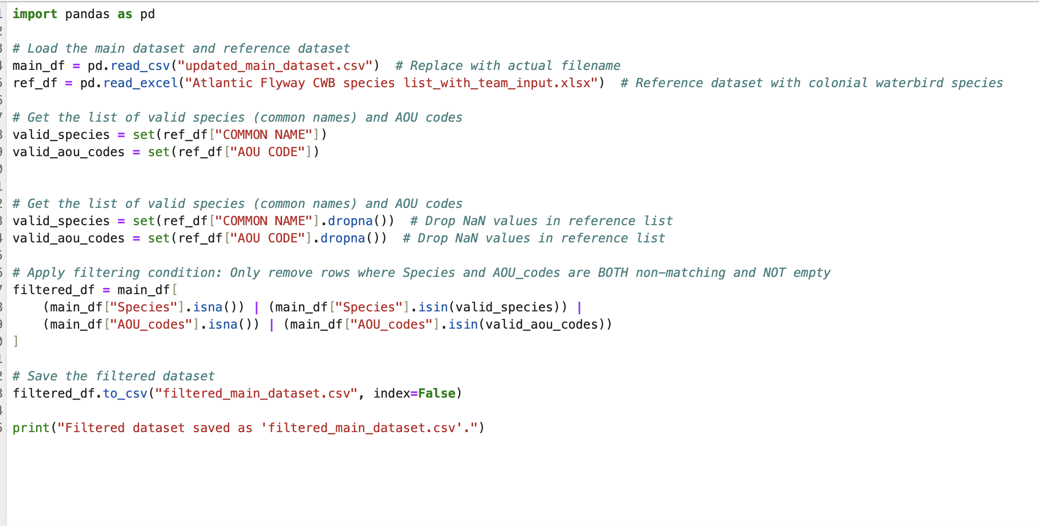

** Note: The Reference list was given by the client named as: “Atlantic Flyway CWB species list_with_team_input.xlsx”

